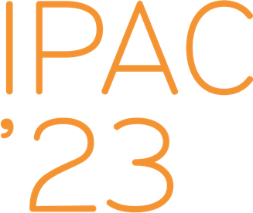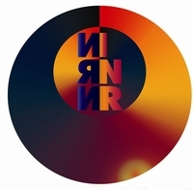

**Reference letter**

**for IPAC’23 student grant application for a PhD student Sergey Kolokol’chikov**

I am writing this reference letter forSergey Kolokol’chikov, a PhD student I was fortunate to work with during 5 years. As both Sergey’s academic advisor and professor of Institute for Nuclear Research of the Russian Academy of Sciences (INR RAS). We works together in collaboration with Joint Institute for Nuclear Researches (JINR) for Nuclotron-based Ion Collider fAcility (NICA) project and Moscow Institute of Physics and Technology (MIPT). The main activities of Sergey are in the scope of Electric Dipole Moment (EDM) search at storage rings. EDM search is an advanced field of accelerator physics.

For EDM experiments an update of the NICA magneto-optical structure of straight sections was required. The findings of Sergey serve as a guideline for tuning of the operating machine NICA. Also, Sergey consider the second order of spin coherence correction. It defines an important spin coherence time, which is a final sensitivity of deuteron EDM search. Also, Sergey's research area covers the study of the conservation of polarization during the transition energy crossing with Barrier Bucket RF.

Such international conference as IPAC’23 can make a huge influence in a carrier of young graduate students. In conclusion, I would highly recommend Sergey Kolokol’chikov for this conference and he will be a positive addition to the program.

**Scientific supervisor**

**Dr. Sci., prof., leading accelerator scientist at INR RAS**

**Yury Senichev (y.senichev@inr.ru)**